NAAN MUDHALVAN

MERN stack powered by Mongo DB

**TEAM-7**

**BOOK STORE**

SRIVIDYA R - 2021506107

SHRUTI R - 2021506098

KAVISRI S - 2021506037

SOWMIYA J – 2021506103

**INTRODUCTION:**

Book Ease, a Book Store Management System is a platform designed to streamline the process of managing and organizing a bookstore's inventory, sales, and customer interactions. The primary objective of the system is to enhance the overall efficiency of book management by providing a user-friendly interface for bookstore owners, staff, and customers. The system aims to address key challenges such as tracking book availability, managing customer orders, handling payments, and ensuring smooth inventory operations. By automating various tasks and processes, this system ensures better organization, timely updates, and improved customer satisfaction.

**PROBLEM STATEMENT:**

Sarah is an avid reader with a passion for exploring new genres and authors. However, her busy schedule often leaves her with limited time to visit physical bookstores. Sarah is looking for a solution that allows her to discover and purchase books conveniently, without compromising her reading preferences or the joy of browsing through a bookstore.

**User Registration and Authentication:** Allow users to register accounts securely, log in, and authenticate their identity to access the book store platform.

**Book Listings:** Display a comprehensive list of available books with details such as title, author, genre, description, price, and availability status.

**Book Selection:** Provide users with options to select their preferred books based on factors like genre, author, ratings, and popularity.

**Purchase Process:** Allow users to add books to their cart, specify quantities, and complete purchases securely. Upon successful completion, an order is generated, and the inventory is updated accordingly.

**Order Confirmation:** Provide users with a confirmation page or notification containing details of their order, including book information, total price, and order ID.

**Order History:** Allow users to view their past and current orders, providing options to track shipments, review purchased books, and rate their shopping experience.

**ROLES AND RESPONSIBILITY:**

**User:**

* **Registration:** Users are responsible for registering an account on the BookEase book store app by providing essential details such as name, email, and password.
* **Profile Management:** Users have the capability to manage their profiles, allowing them to update information like email, name, and password.
* **Book Browsing:** Users can browse through the available books, explore different genres, and search for specific titles or authors.
* **Purchase:** Users can add books to their cart, specify quantities, and complete purchases securely.
* **Feedback:** Provide feedback and ratings for purchased books and sellers on the BookEase platform.
* **Logout:** Lastly, they can logout from the BookEase book store app.

**Seller:**

* **Registration:** Sellers register an account on the BookEase book store app by providing necessary details such as business name, email, and password.
* **Profile Management:** Sellers have the capability to manage their profiles, allowing them to update information like email, business name, and password.
* **Book Listing:** Sellers can add new books to the platform, including details such as title, author, genre, description, price, and quantity available.
* **Inventory Management:** Sellers can manage their book inventory, updating stock levels, removing inactive listings, and handling book ratings.
* **Order Fulfillment:** Sellers are responsible for fulfilling orders placed by users, including packaging and shipping books in a timely manner.
* **Logout:** Finally, they can logout from the BookEase book store app.

**Admin:**

* **System Management:** Admins have full control over all aspects of the book store system, overseeing functionalities, configurations, and security.
* **User Management:** Admins can manage user information, including creating, updating, and deleting accounts. They also have authority over user ratings.
* **Book Management:** Admins can manage book listings, including adding new books, updating details, and removing inactive listings from the platform.
* **Seller Management:** Admins have the authority to manage seller information, including approving new seller accounts, updating profiles, and handling seller ratings.
* **Logout:** Finally, they can logout from the BookEase book store app.

**ER- DIAGRAM:**

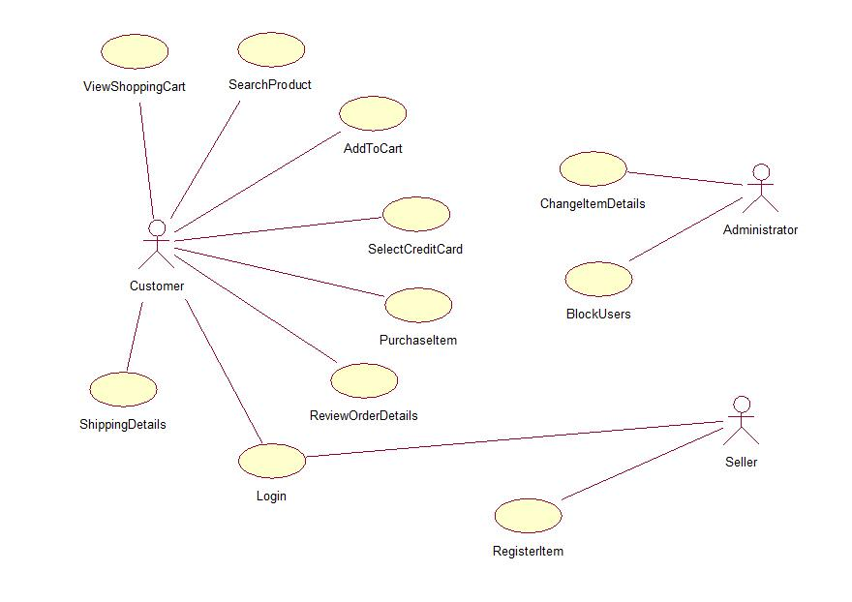

**IMPLEMENTATION:**

**Home Page:**



**Slider Section:**

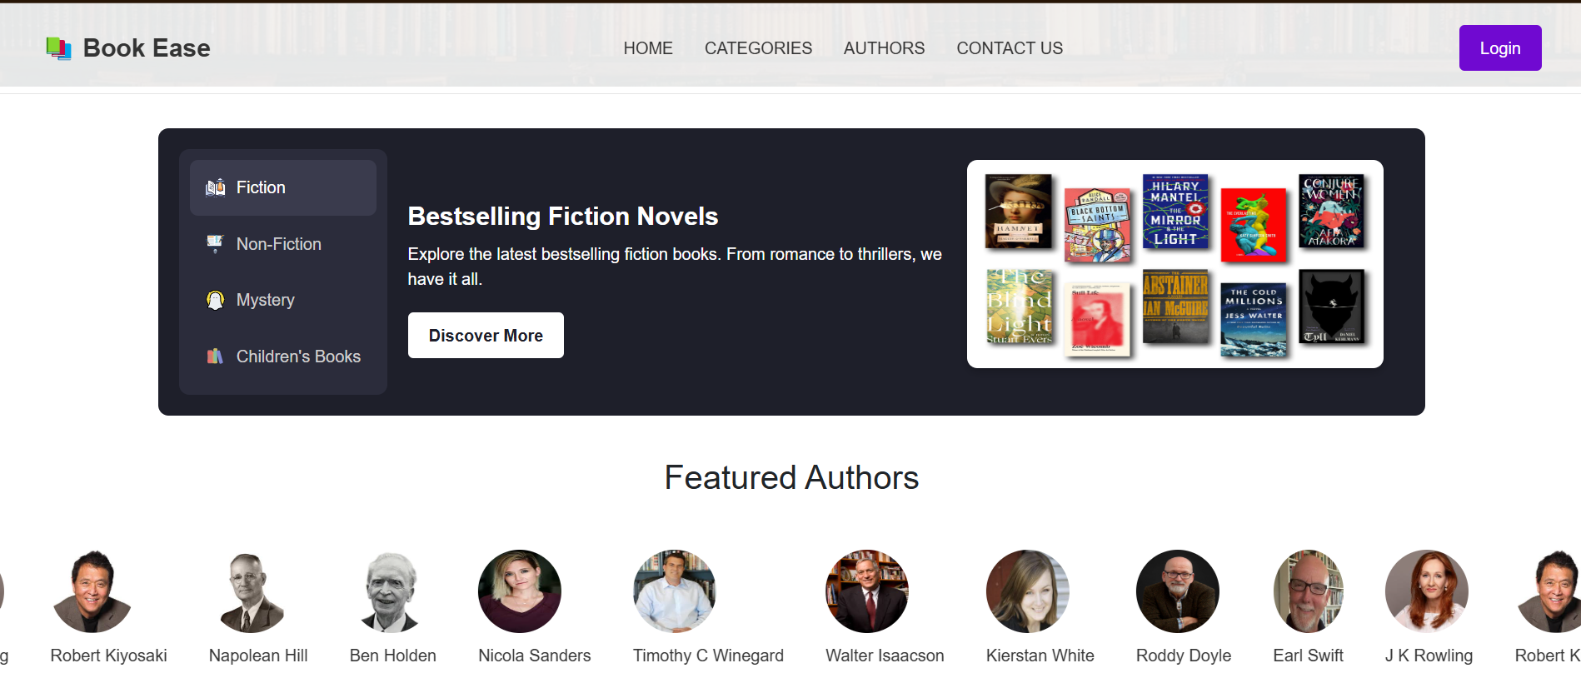

**Login Options:**

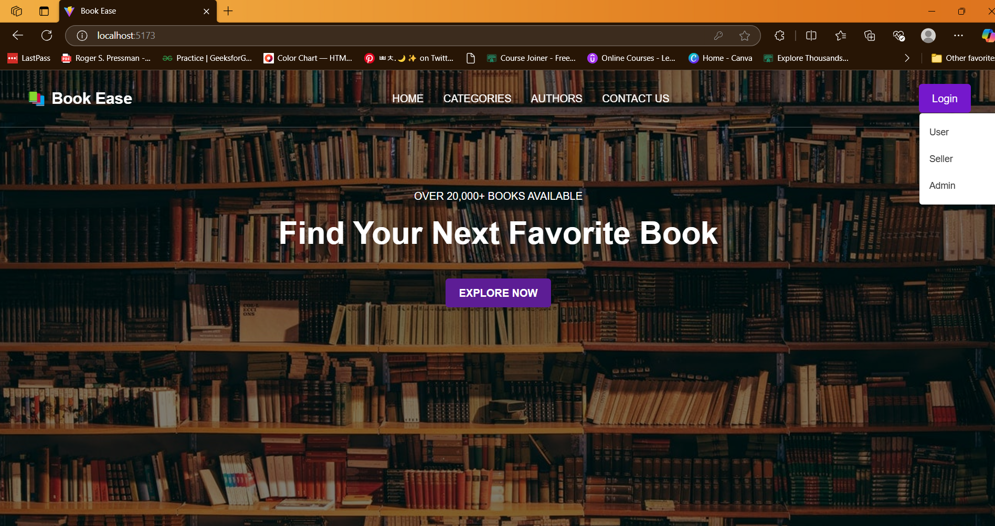

**User Signup and Login Page**

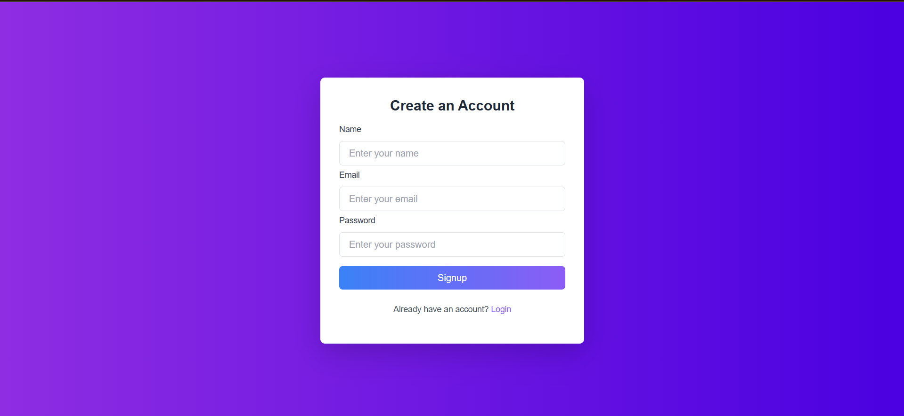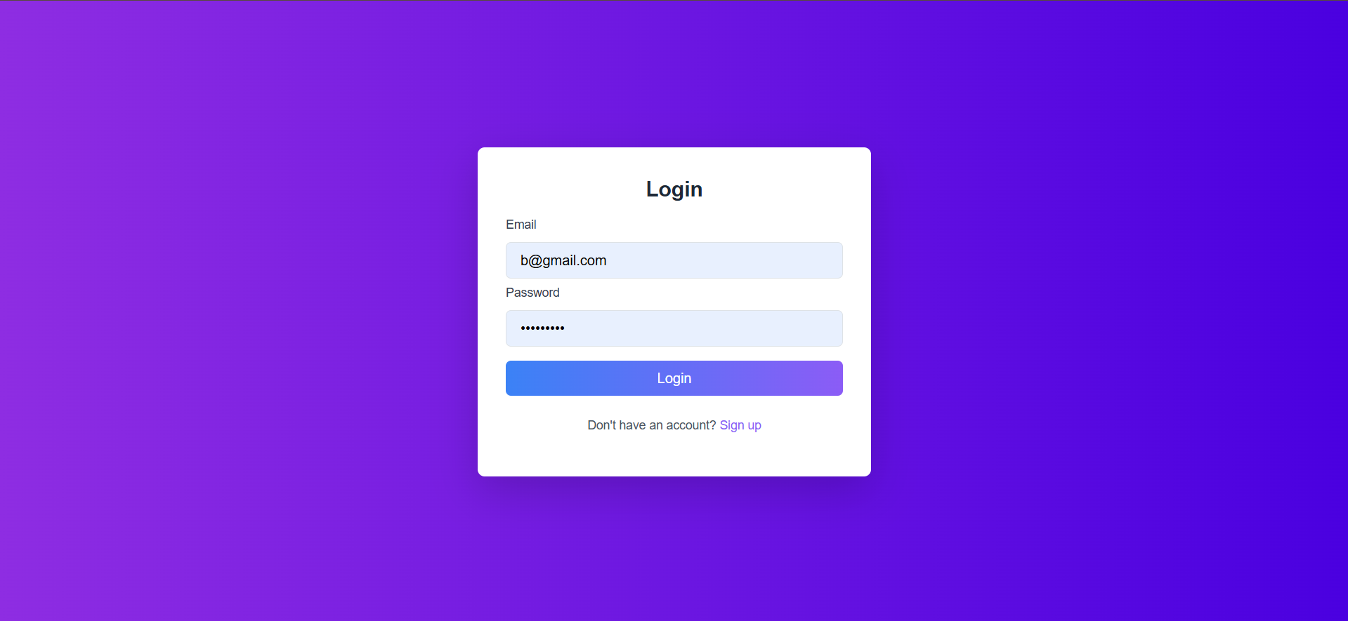

**Successful Login Message:**

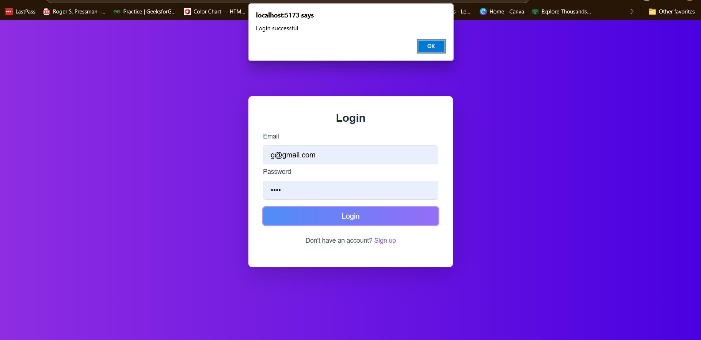

**User Home Page:**



**Books Display:**

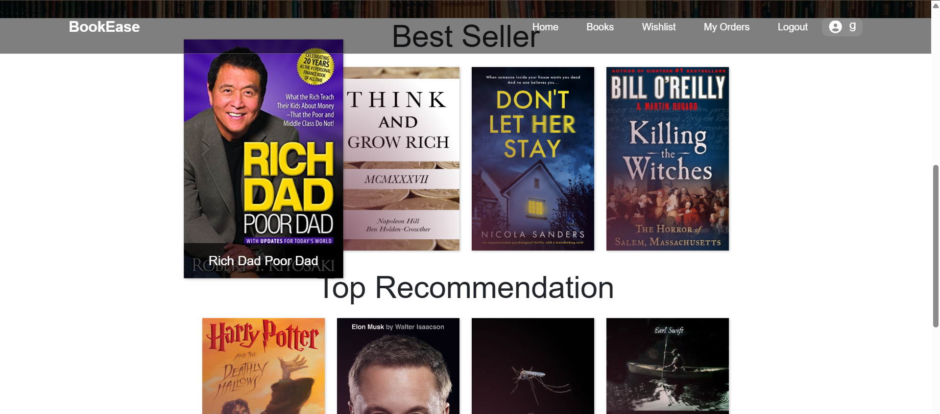

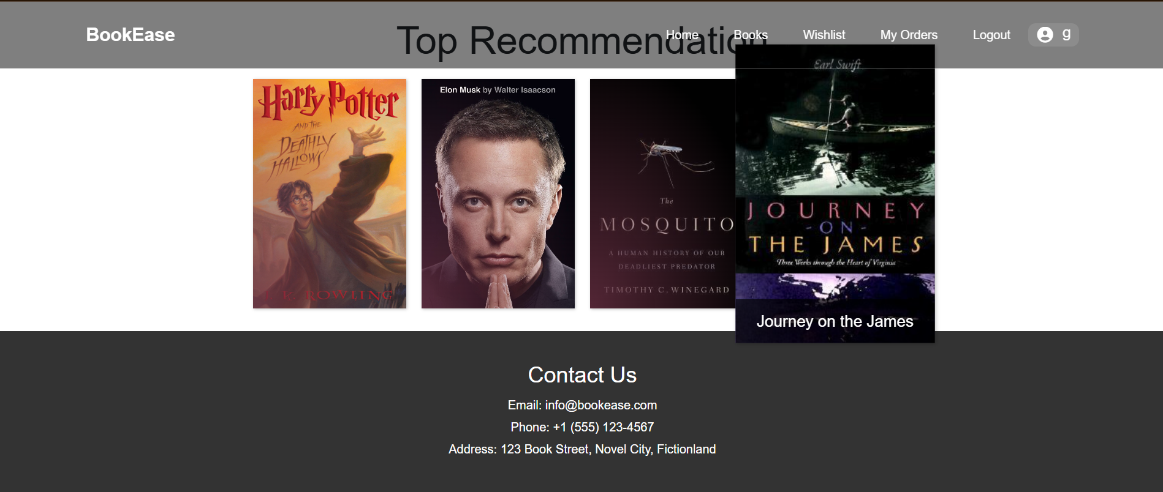

**Books Page with Search bar:**



**Filtered Books:**

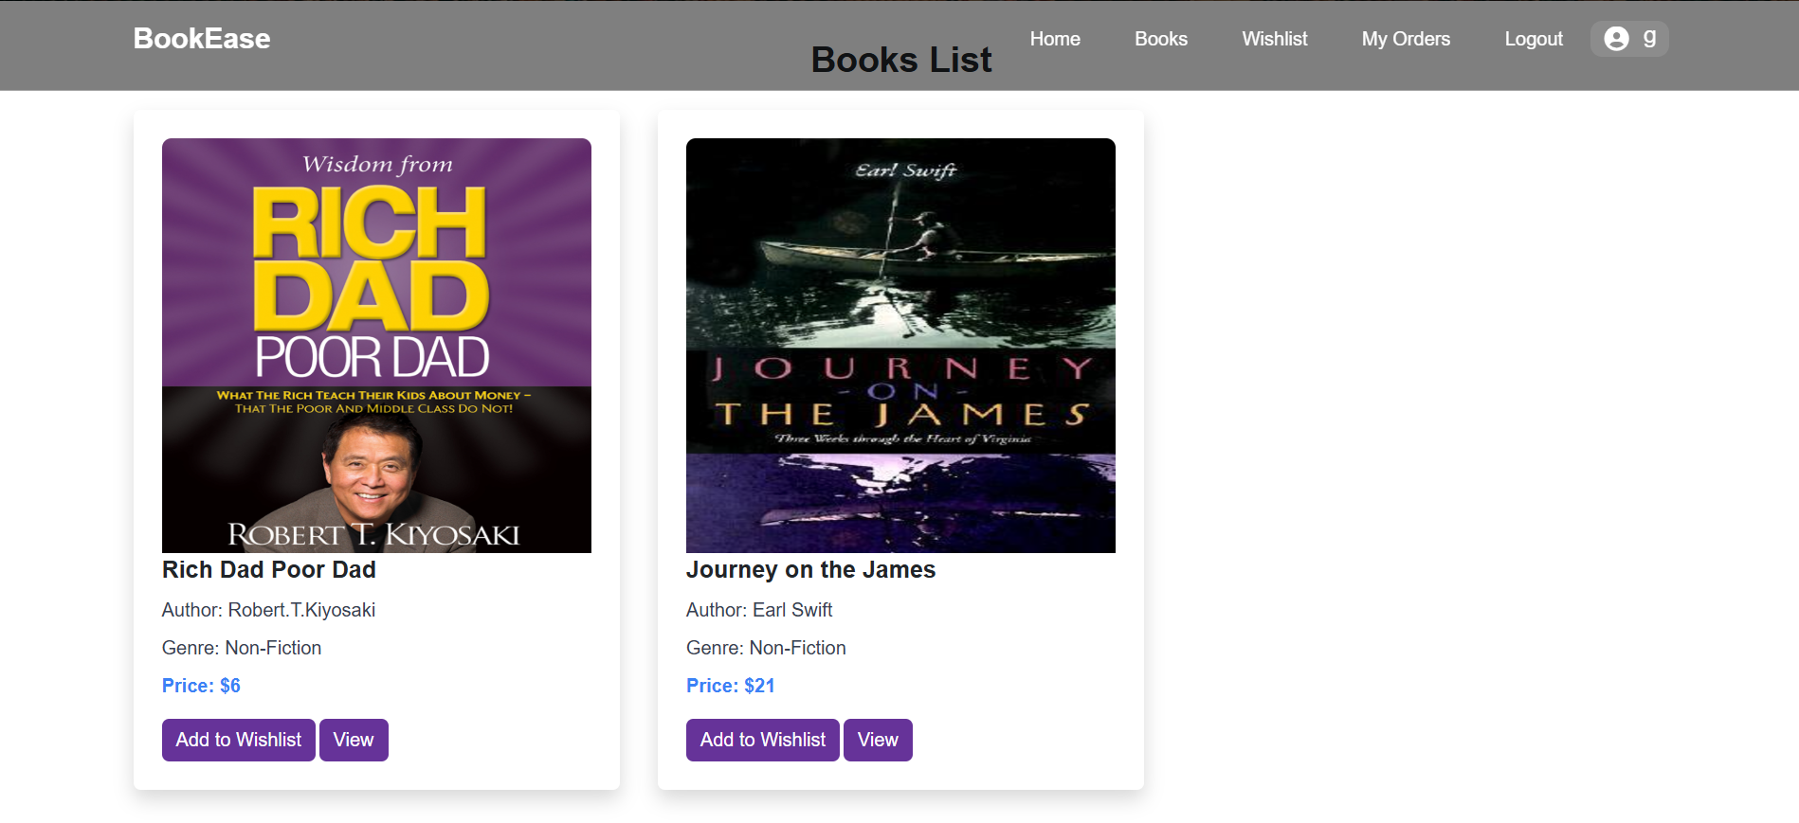

**Book Added to Wishlist:**

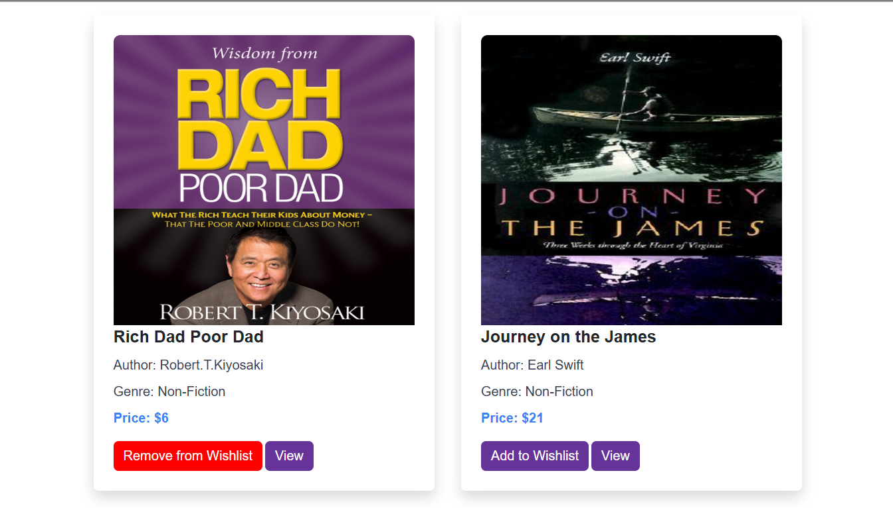

**Wishlist:**

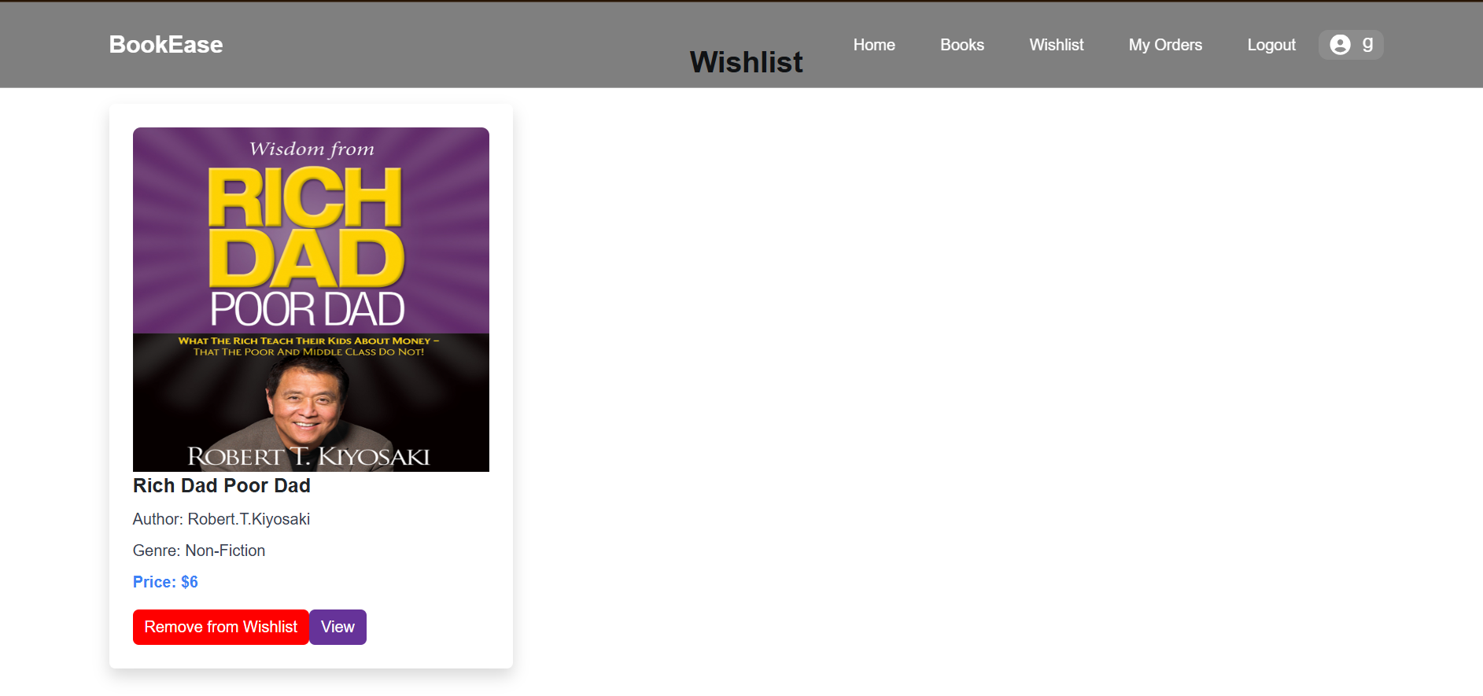

**View Page:**

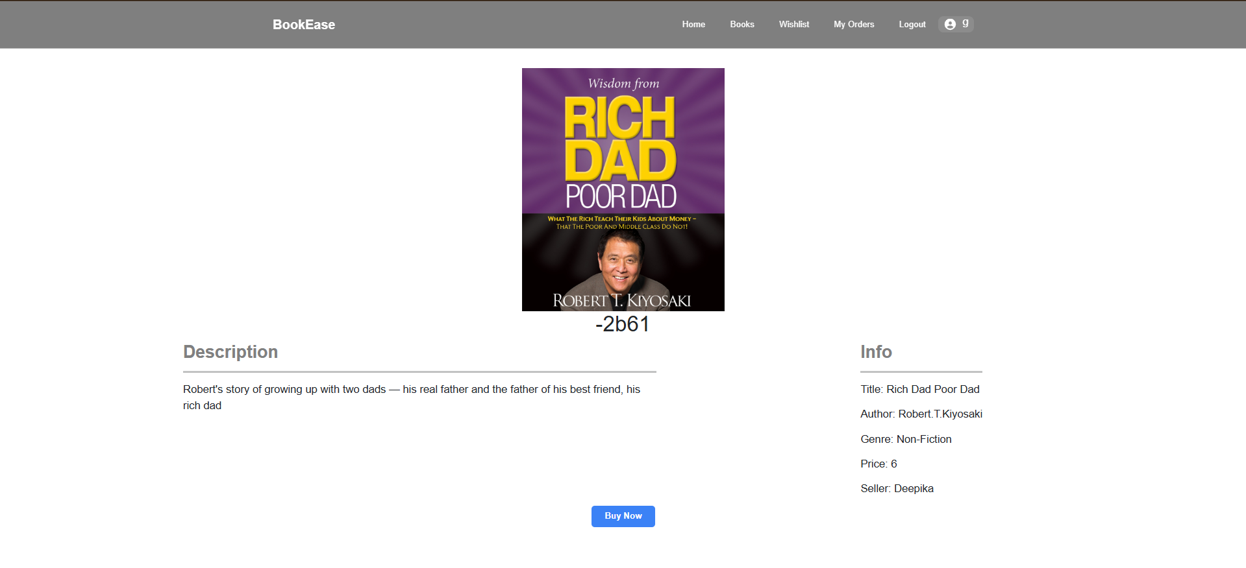

**Order Page:**

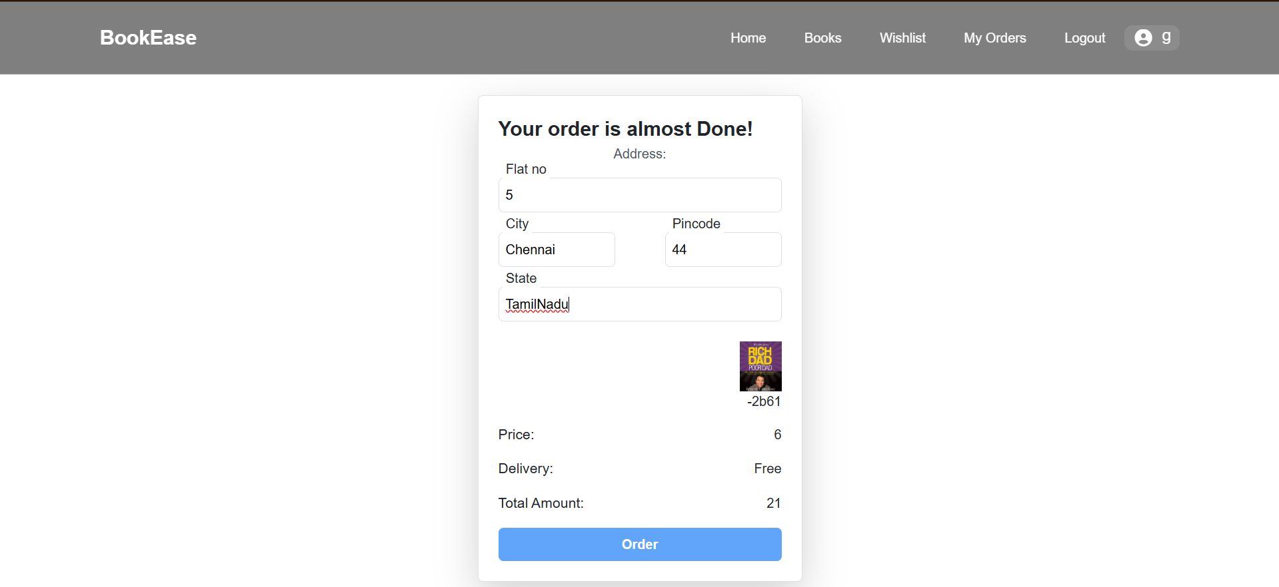

**Order Successful Message:**

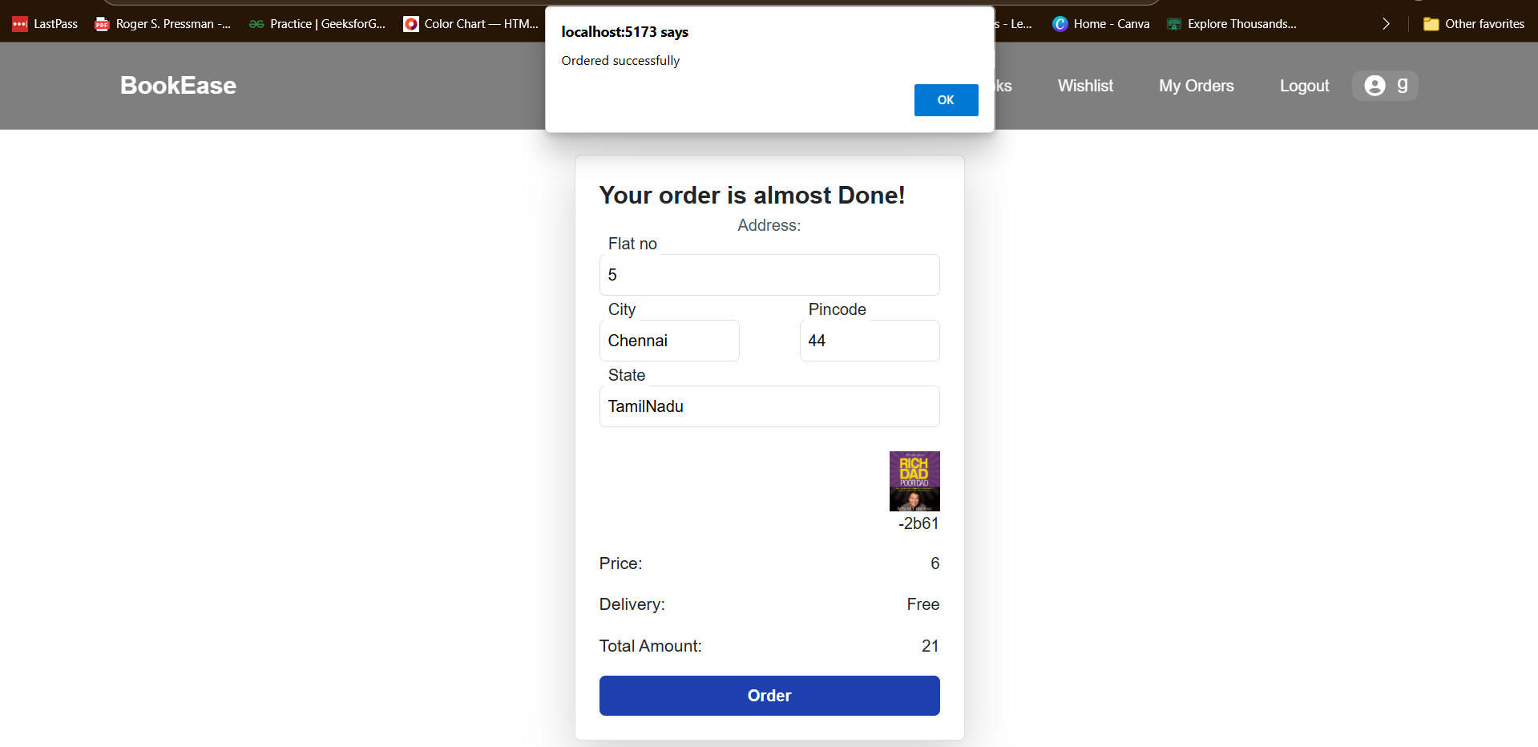

**Orders List:**

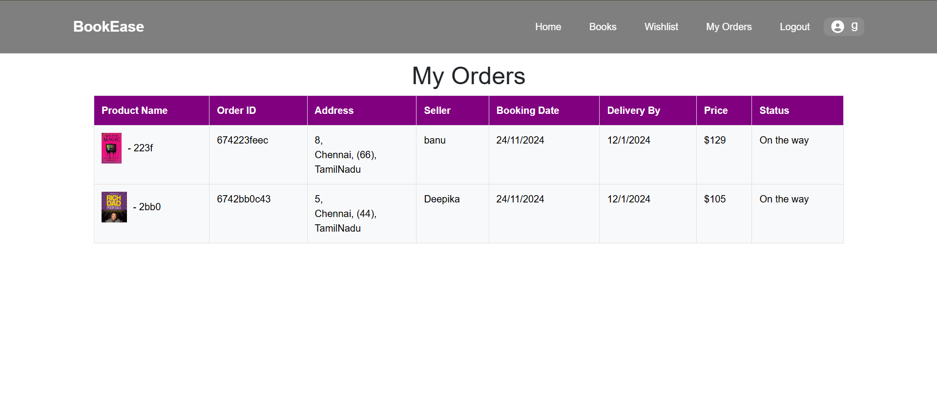

**Seller Registration and Login Page:**

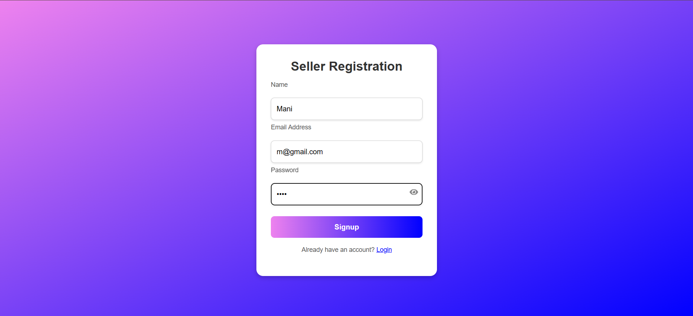

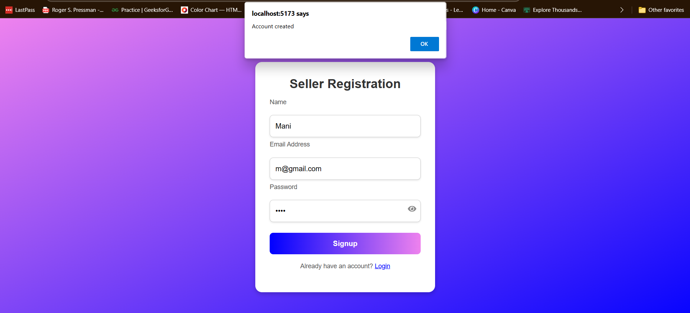

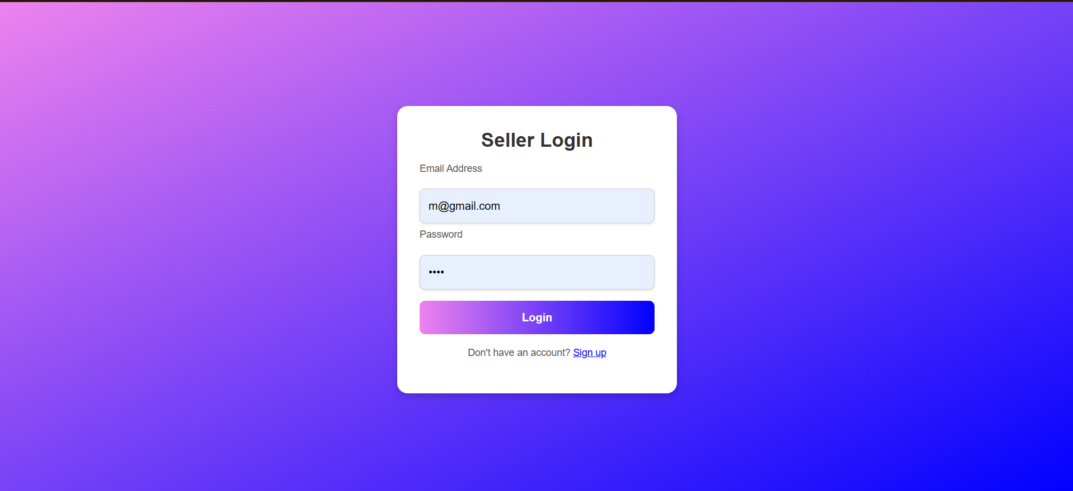

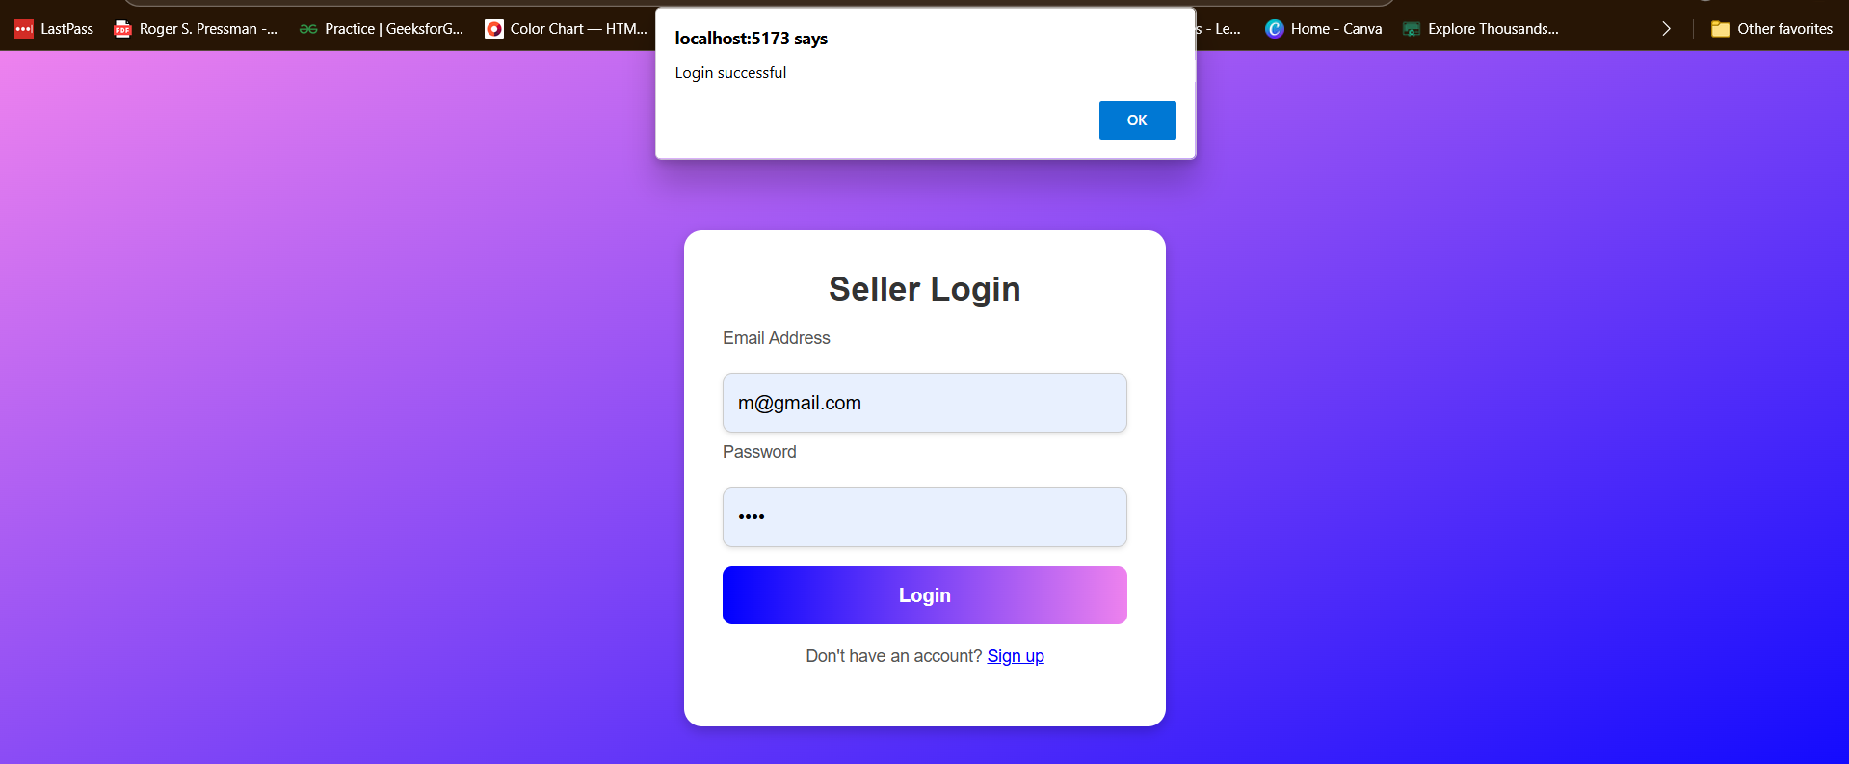

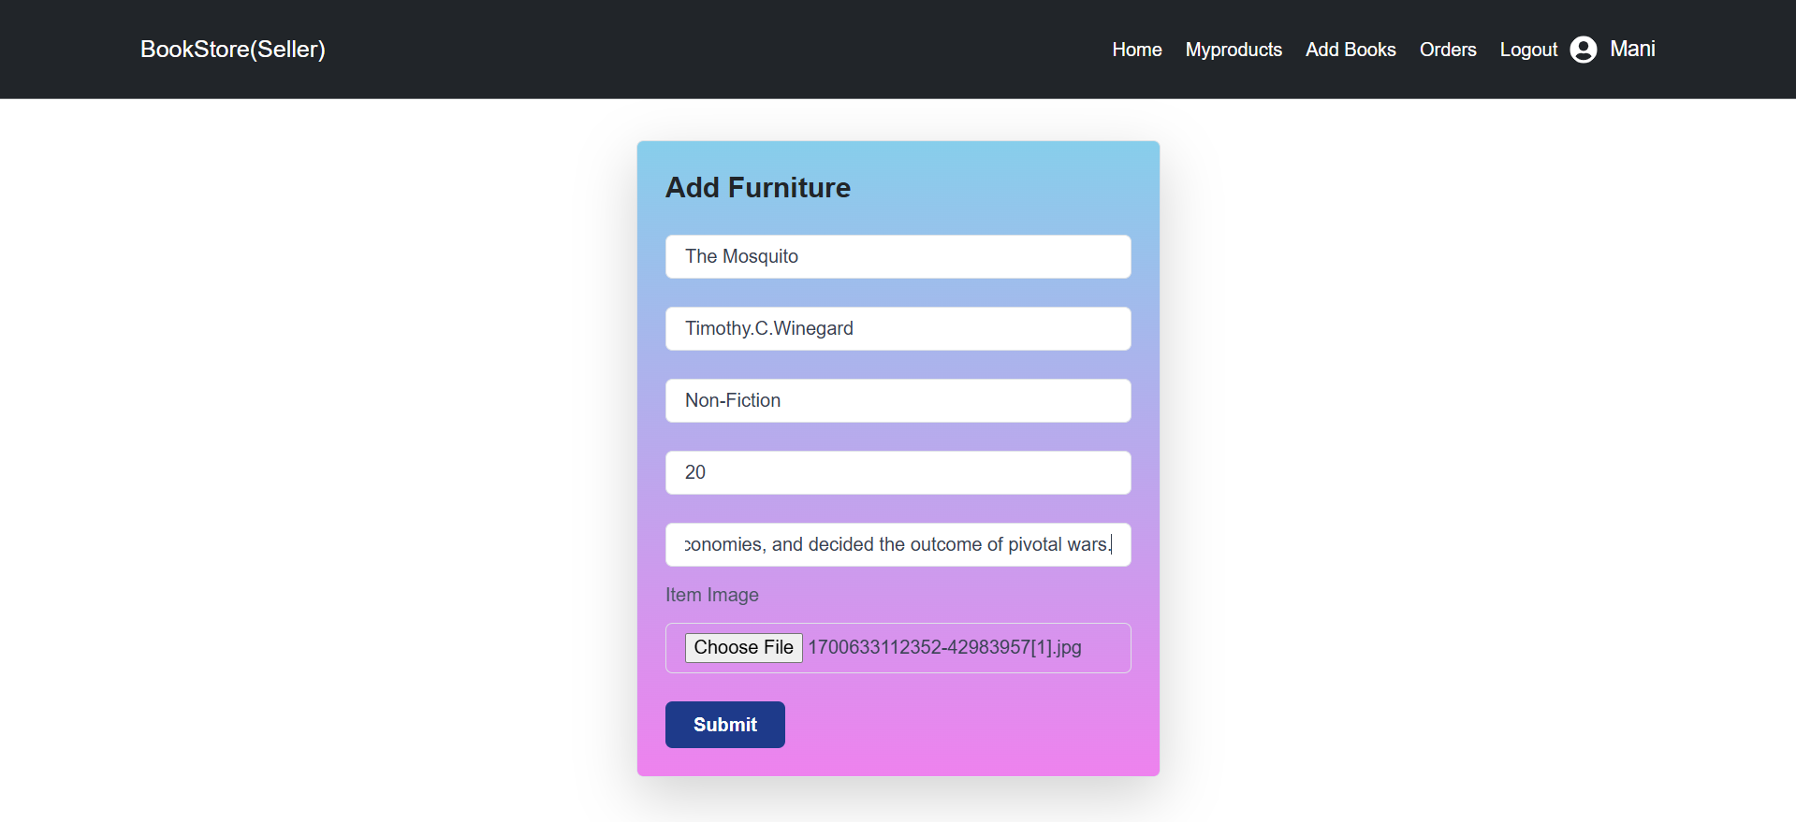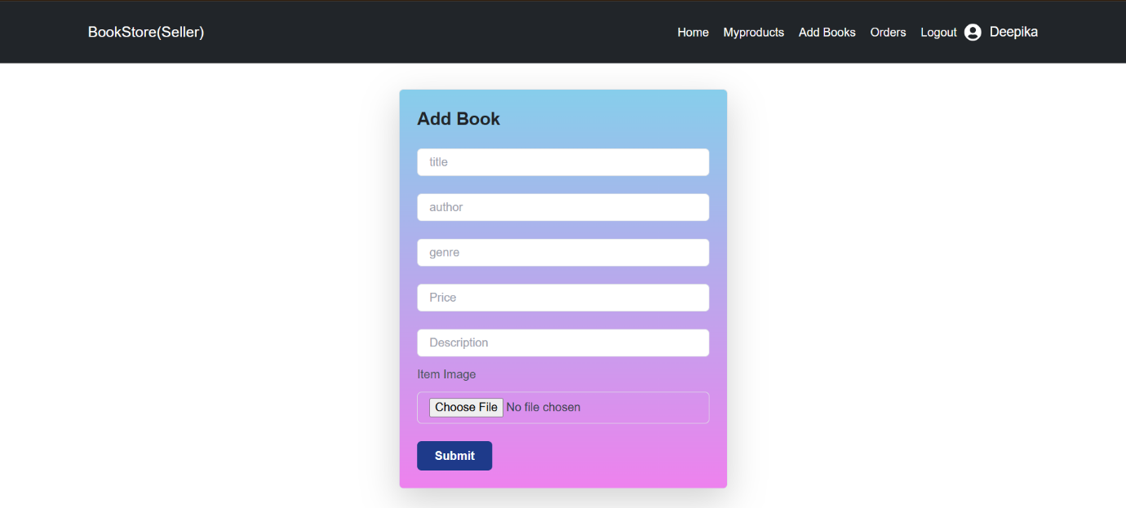

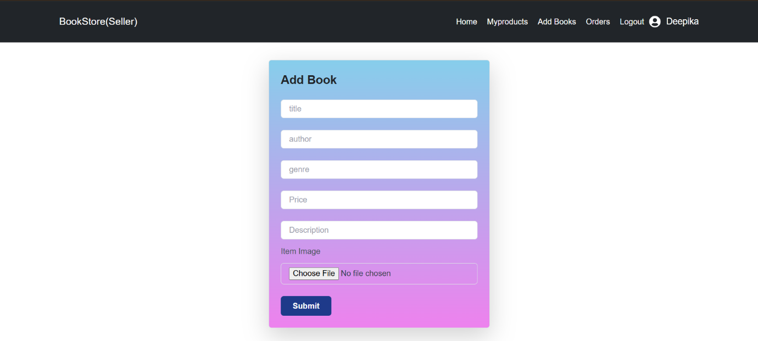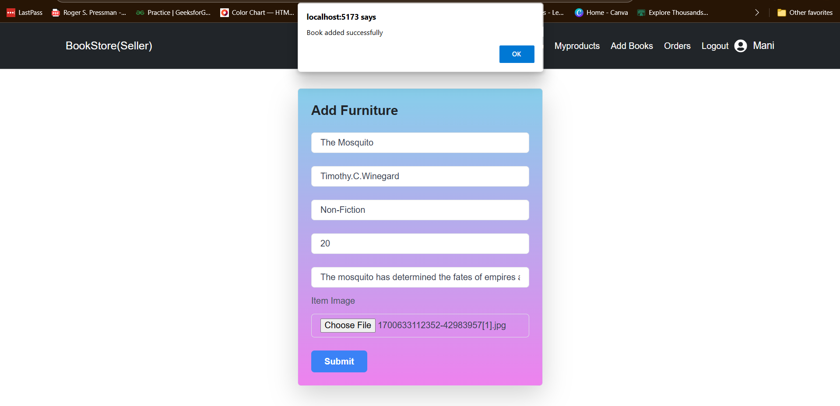

**Books List:**

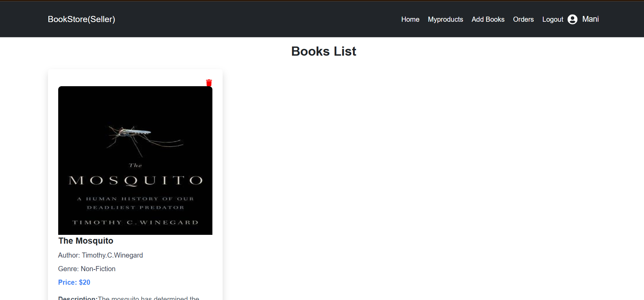

**Deleting Items:**

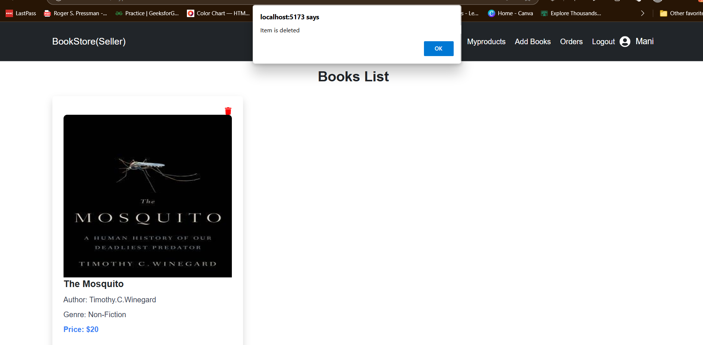

**Seller Home/Dashboard:**

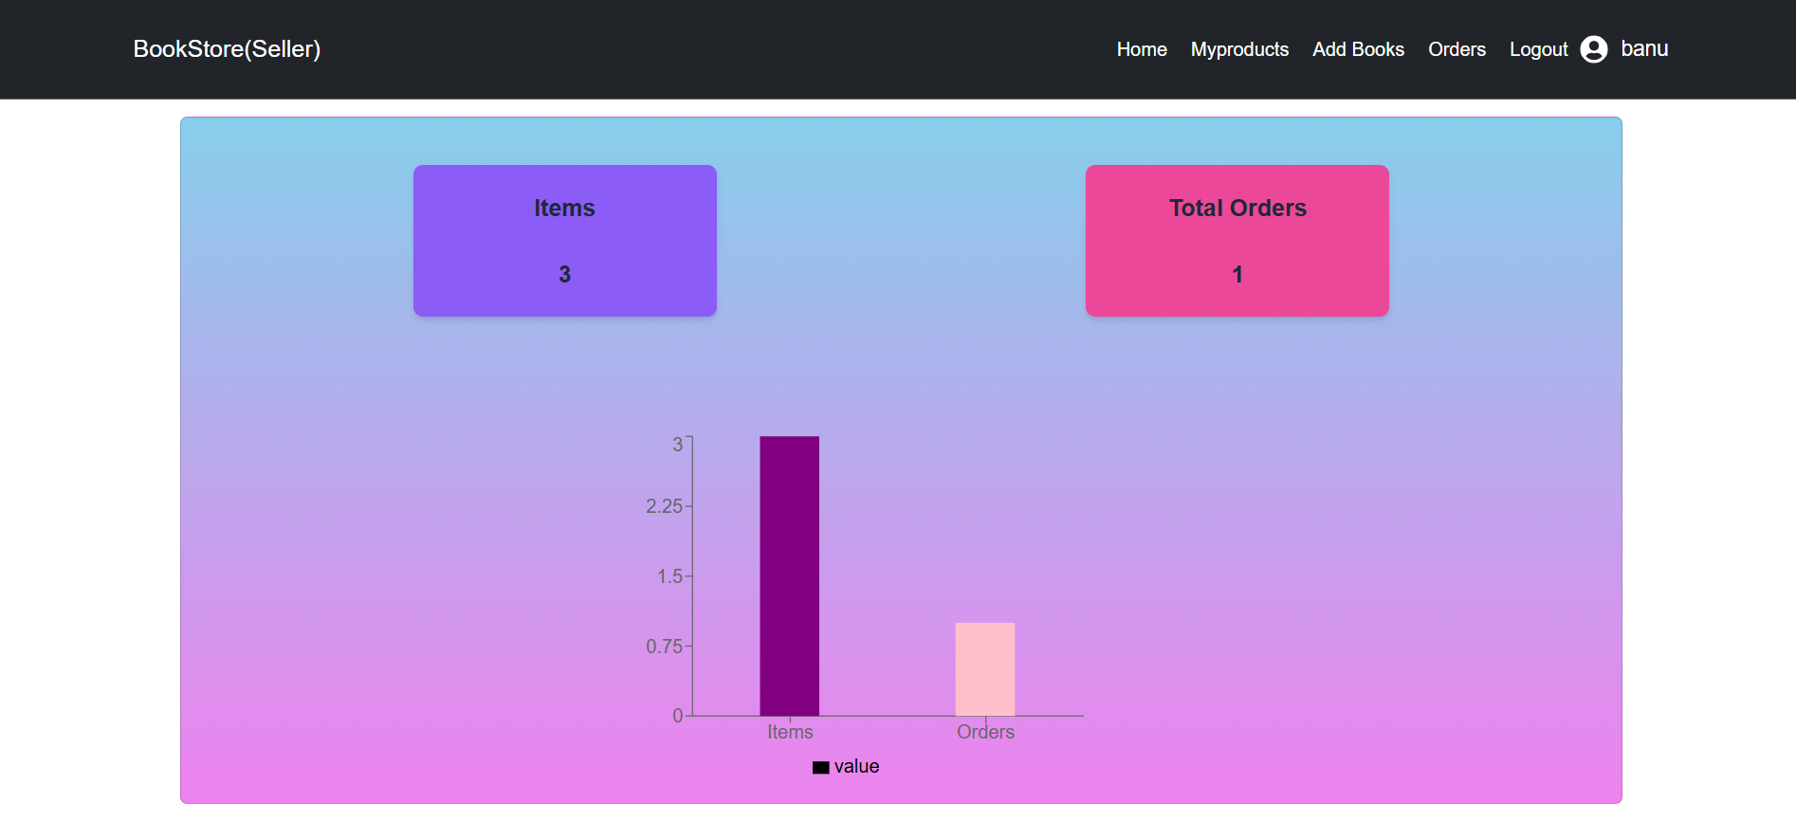

**Orders Page:**

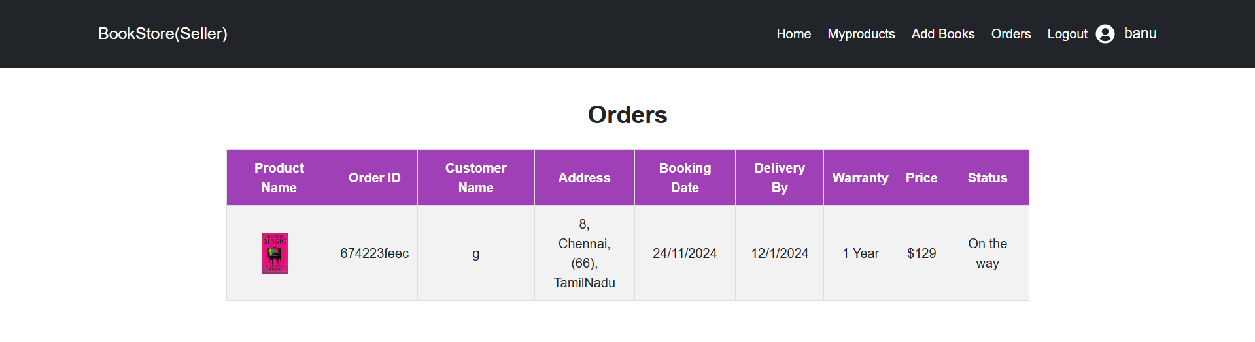

**Admin Registration and Login page:**

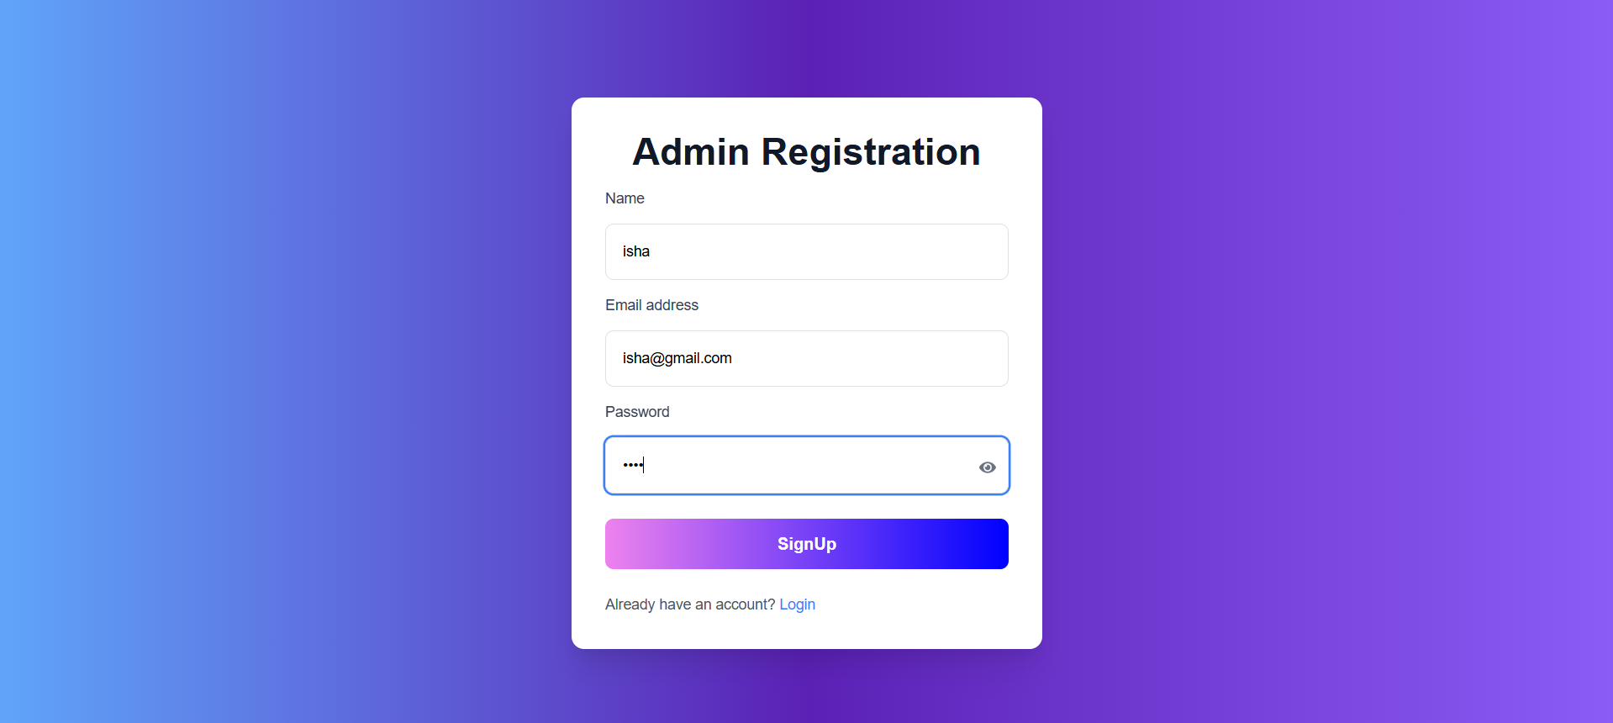

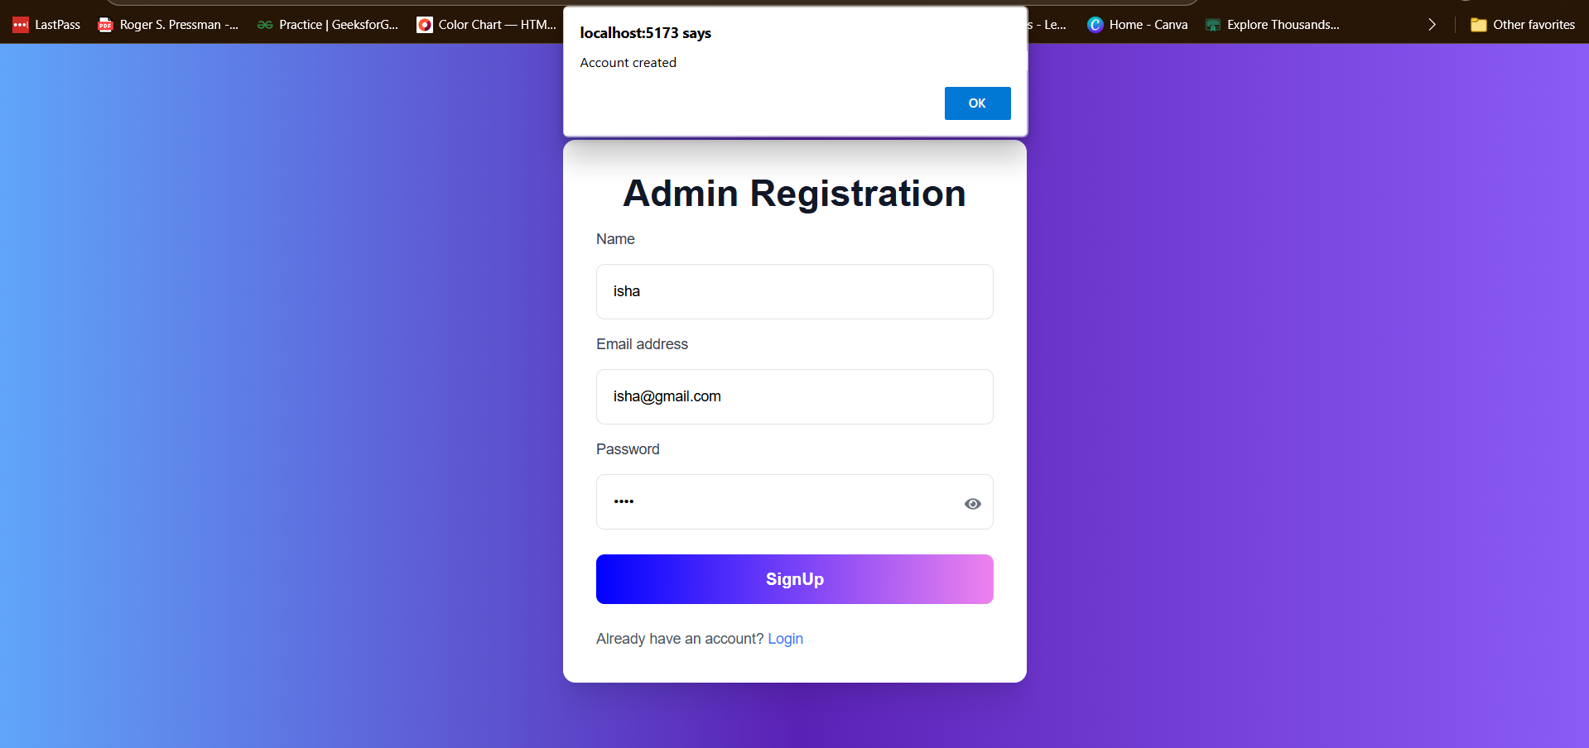

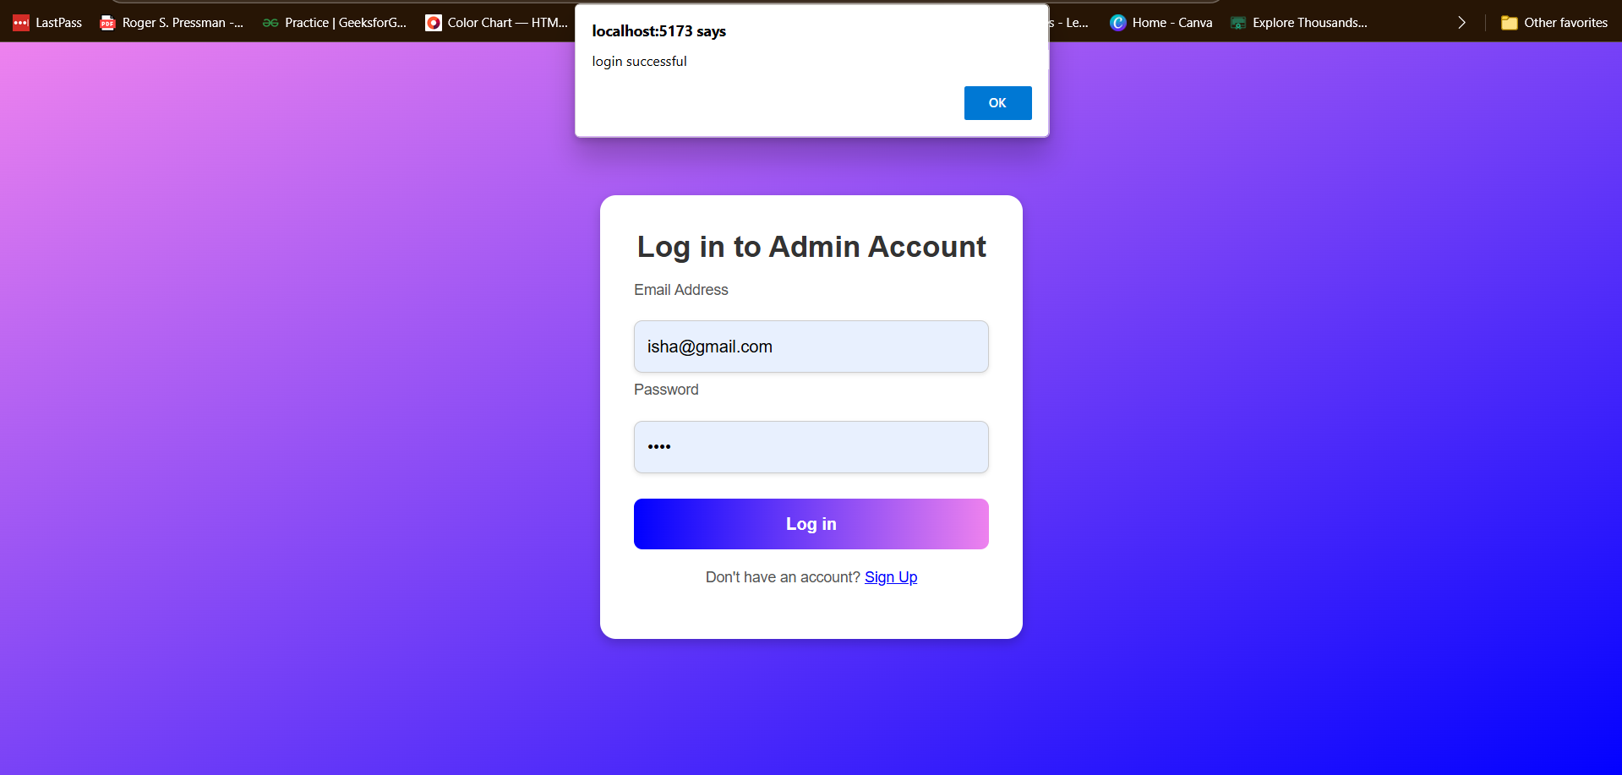

**Admin DashBoard:**

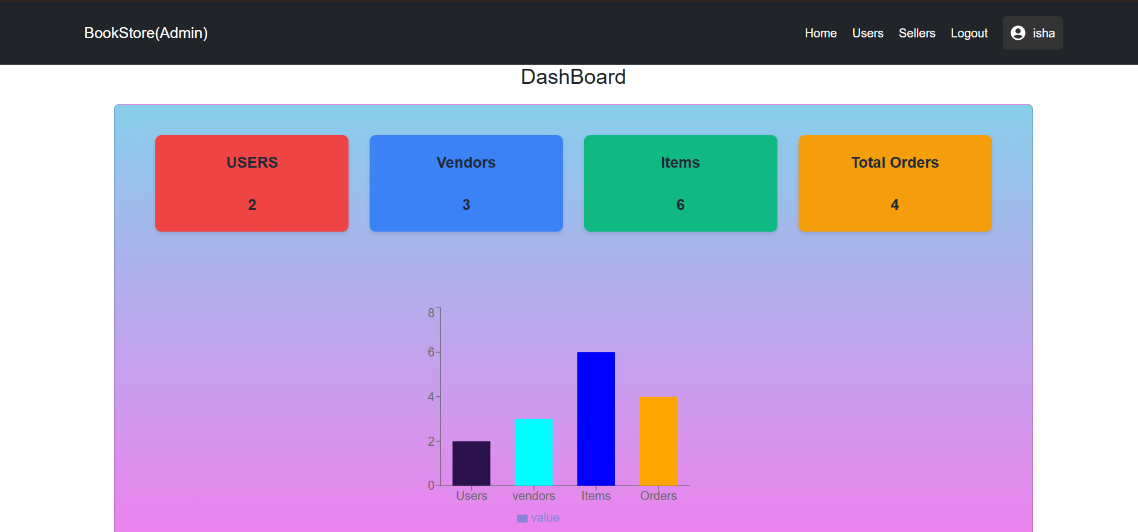

**Users List:**

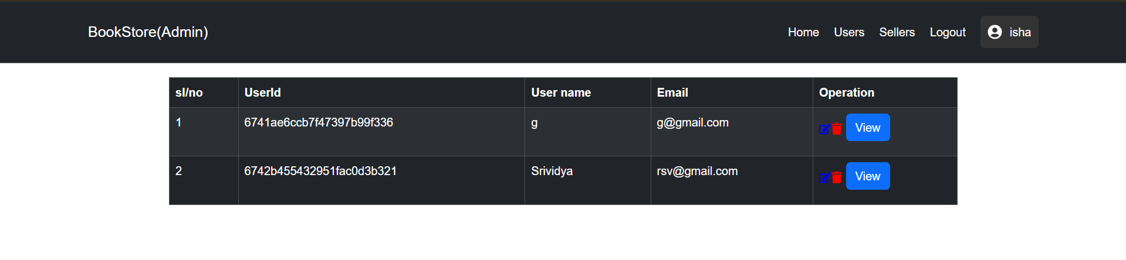

**Sellers List:**

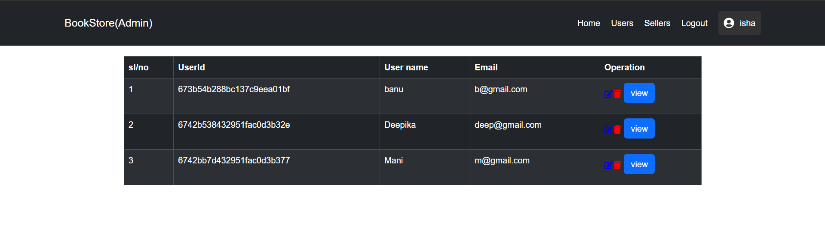

**CONCLUSION:**

In conclusion, the Book Store Management System serves as an effective solution for simplifying and automating the various aspects of bookstore operations. By integrating inventory management, order processing, and customer interaction into a unified platform, the system offers enhanced operational efficiency, reducing the manual effort required to maintain records and track sales. The ability to provide real-time updates on stock availability and streamline the ordering process ensures that customers have a seamless shopping experience. Moreover, the system's user-friendly interface and automated features make it an invaluable tool for bookstore owners and staff, ultimately contributing to improved management practices, higher customer satisfaction, and increased profitability.